**UNIT – III**

**Single Phase AC Circuits:** Concept of Active and reactive power, power factor –power triangle. Examples Steady state Analysis of R, L and C elements (in series, parallel and series parallel combinations) –with sinusoidal Excitation - Phasor diagrams-Examples

**Power:**

In an AC circuit, the various powers can be classified as

1. Real or Active power or Average power.

2. Reactive power

3. Apparent power

Real or active power in an AC circuit is the power that does useful work in the circuit. Reactive power flows in an AC circuit but does not do any useful work. Apparent power is the total power in an AC circuit.

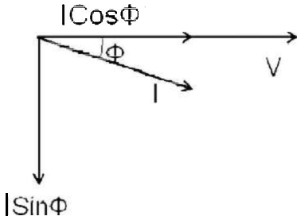

Fig 3.1

**Instantaneous Power:**

The instantaneous power is product of instantaneous values of current and voltages and it can be derived as follows

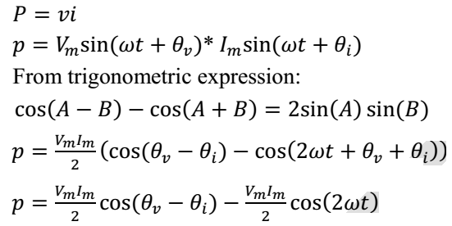

The instantaneous power consists of two terms. The first term is called as the constant power term and the second term is called as the fluctuating power term.

**Average Power:**

From instantaneous power we can find average power over one cycle as following.

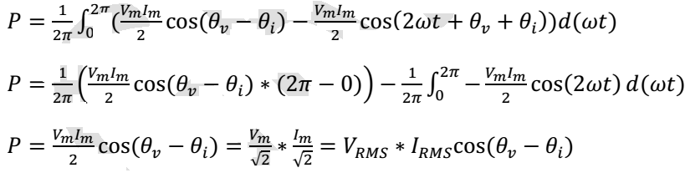

As seen above the average power is the product of the RMS voltage and the RMS current.

**Real Power:**

The power due to the active component of current is called as the active power or real power. It is denoted by P.



Real power is the power that does useful power. It is the power that is consumed by the resistance. The unit for real power is Watt (W).

**Reactive Power:**

The power due to the reactive component of current is called as the reactive power. It is denoted by Q.



Reactive power does not do any useful work. It is the circulating power in the L and C components. The unit for reactive power is Volt Amperes Reactive (VAR).

**Apparent Power:**

The apparent power is the total power in the circuit. It is denoted by S.

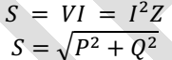

The unit for apparent power is Volt Amperes (VA).

**Power Triangle:**

From the impedance triangle, another triangle called the power triangle can be derived as shown.

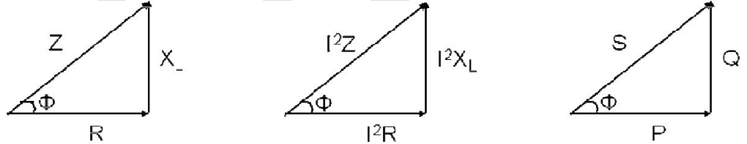

Fig.3.2 a Fig.3.2b Fig3.2c

The power triangle is right angled triangle with P and Q as two sides and S as the hypotenuse. The angle between the base and hypotenuse is Φ. The power triangle enables us to calculate the following things.

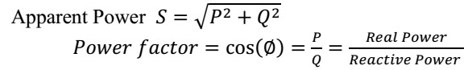

The power Factor in an AC circuit can be calculated by any one of the following Methods

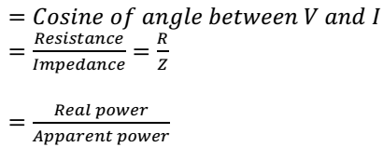

**Single phase circuits with Sinusoidal AC excitation**

**Pure Resistance**

Consider a perfect (pure) resistor, connected to an a.c. supply, as shown in Fig. 3.3. The current

flowing at any instant is directly proportional to the instantaneous applied voltage, and inversely proportional to the resistance value. The voltage is varying sinusoidally, and the resistance is a constant value. Thus the current flow will also be sinusoidal, and will be in phase with the applied voltage. This can be written as follows

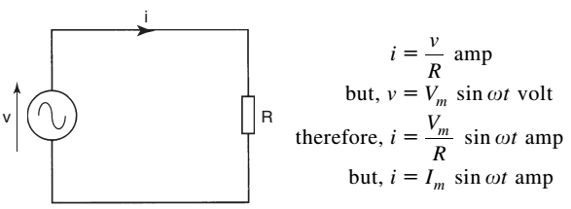

Fig.3.3

Hence,

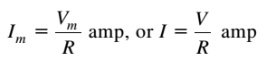

The relevant waveform and phasor diagrams are shown in Figs. 3.4a. and 3.4b. respectively.

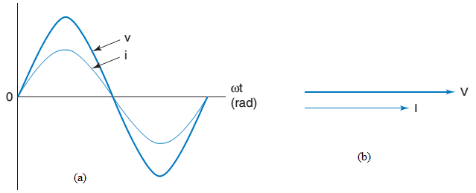

Fig.3.4

The instantaneous power ( p) is given by the product of the instantaneous values of voltage and current. Thus p = vi. The waveform diagram is shown in Fig.3.4a. From this diagram, it is obvious that the power reaches its maximum and minimum values at the same time as both voltage and current. Therefore

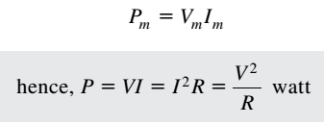

Note: When calculating the power, the r.m.s.values must be used.

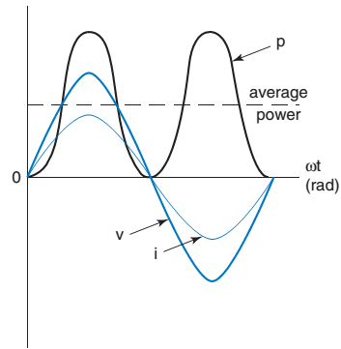

Fig.3.5

From these results, we can conclude that a pure resistor, in an a.c. circuit, behaves in exactly the same way as in the equivalent d.c. circuit.

**Pure Inductance**

Consider a pure inductor, connected to an a.c. supply, as shown in Fig.3.6.

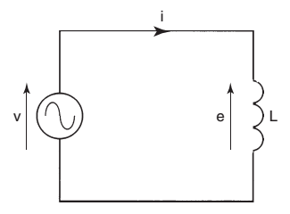

Fig.3.6

An alternating current will now flow through the circuit. Since the current is continuously changing, then a back emf, e will be induced across the inductor. In this case, e will be exactly equal and opposite to the applied voltage, v. the equation for this back emf is



E will have its maximum values when the rate of change of current, d i/d t, is at its maximum values. These maximum rates of change occur as the current waveform passes through the zero position. The related waveforms are shown in Fig. 3.7 a . From this waveform diagram, it may be seen that the applied voltage, V leads the circuit current, I, by π /2 rad, or 90°. The corresponding phasor diagram is shown in Fig. 3.7 b.

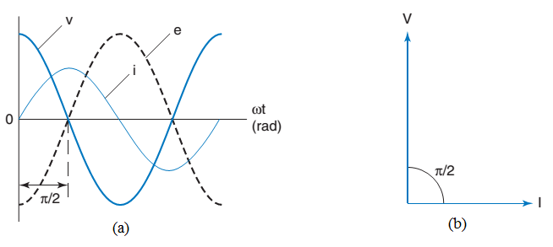

Fig.3.7

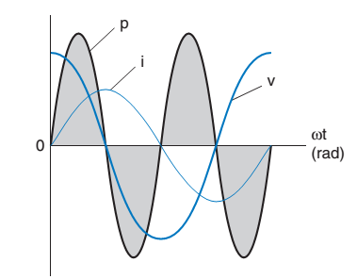

Fig.3.7 c

**Inductive Reactance**

Inductive reactance is defined as the opposition offered to the flow of a.c., by a perfect inductor. It is measured in ohms, and the quantity symbol is X L

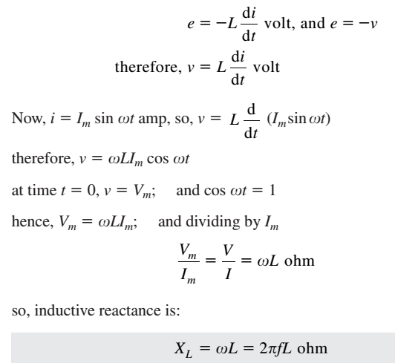



**Pure Capacitance**

Consider a perfect capacitor, connected to an a.c. supply, as shown in Fig.3.8a. The charge on the capacitor is directly proportional to the p.d. across it. Thus, when the voltage is at its maximum, so too will be the charge, and so on. The waveform for the capacitor charge will therefore be in phase with the voltage. Current is the rate of change of charge. This means that when the rate of change of charge is a maximum, then the current will be at a maximum, and so on.. The resulting waveforms are shown in Fig.3.8b. It may therefore be seen that the current now leads the voltage by π/2 rad, or 90°.

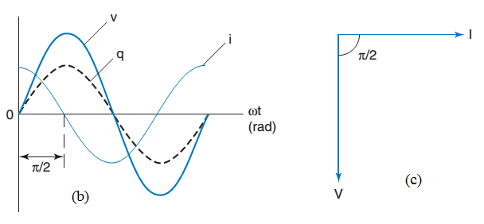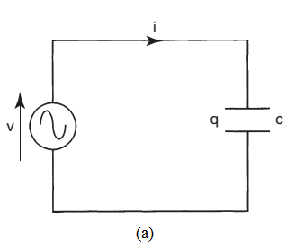

Fig.3.8

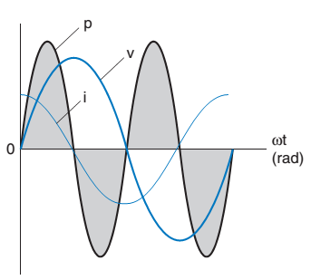

Fig.3.8d

**Capacitive Reactance(X C)**

It is defined as the opposition offered to the flow of a.c. through a perfect capacitor

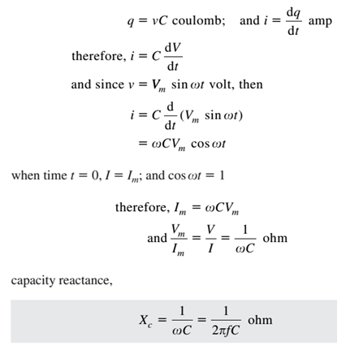

**Impedance**

This is the total opposition, offered to the flow of a.c. current, by a circuit that contains both resistance and reactance. It is measured in ohms, and has the quantity symbol Z.



Where V is the circuit applied voltage, and I is the resulting circuit current.

**Inductance and Resistance in Series**

A pure resistor and a pure inductor are shown connected in series in Fig....... The circuit current, I, will produce the p.d. V R across the resistor, due to its resistance, R. Similarly, the p.d. V L results from the inductor’s opposition, the inductive reactance, X L. Thus, the only circuit quantity that is common, to both the resistor and the inductor, is the circuit current, I. For this reason, the current is chosen as the reference phasor.

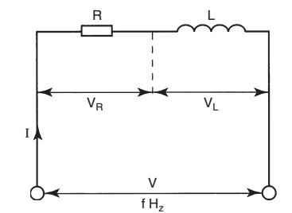

Fig.3.9

The p.d. across the resistor will be in phase with the current through it (Ф = 0). The p.d. across the inductor will lead the current by 90° ( Ф = 90°). The total applied voltage, V, will be the phasor sum of V R and V L. This last statement may be considered as the ‘ a.c. Version’ of Kirchhoff’s voltage law. In other words, the term ‘ phasor sum ’ has replaced the term ‘algebraic sum ’ , as used in d.c. circuits. The resulting phasor diagram is shown in Fig.3.10. The angle Ф, shown on this diagram, is the angle between the circuit applied voltage, V,and the circuit current, I.It is therefore known as the circuit phase angle.

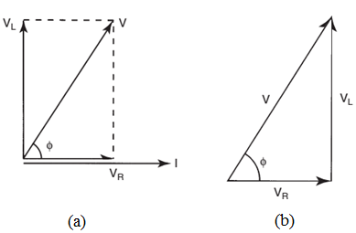

Fig.3.10

The applied voltage Vis the phasor sum of the circuit p.d.s. These p.d.s form horizontal and vertical components.

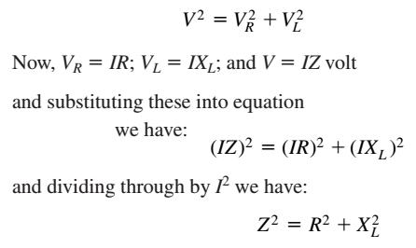



From the last equation, it may be seen that Z, R and XL also form a right-angled triangle. This is known as the impedance triangle, and is shown in Fig.3.11.

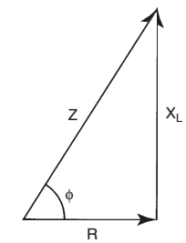

Fig.3.11

From both the voltage and impedance triangles, the following expressions for the circuit phase angle, Ф, are obtained:

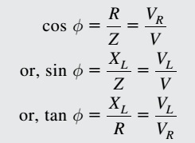

**Resistance and Capacitance in Series**

Figure 3.12 shows a pure capacitor and resistor connected in series, across an a.c. supply. Again, being a series circuit, the circuit current is common to both components. Each will have a p.d. developed. In this case however, the p.d. across the capacitor will lag the current by 90°.

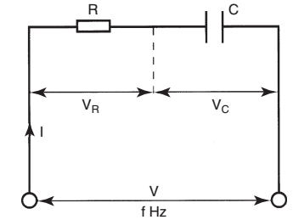

Fig.3.12

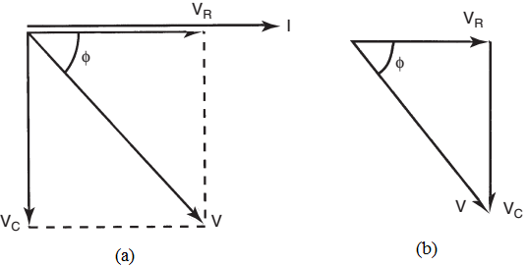

Fig.3.13

The voltage and impedance triangles of RC circuit are shown in Figs.3.13. and .3.14.

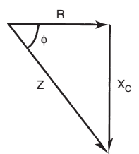

Fig.3.14

The following equations result:

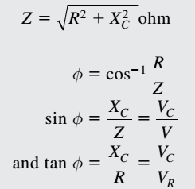

**Resistance, Inductance and Capacitance in Series**

These three elements, connected in series, are shown in Fig. 3.15. Of the three p.d.s, VR will be in phase with the current I, VL will lead I by 90°, and VC will lag I by 90°. The associated phasor diagram is shown in Fig.3.16.

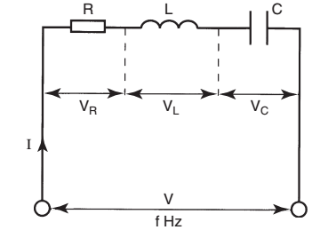

Fig.3.15

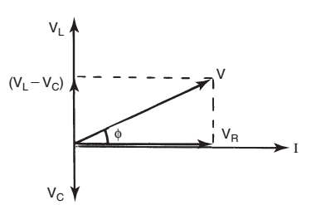

Fig.3.16

The applied voltage V is the phasor sum of the circuit p.d.s. These p.d.s form horizontal and vertical components.

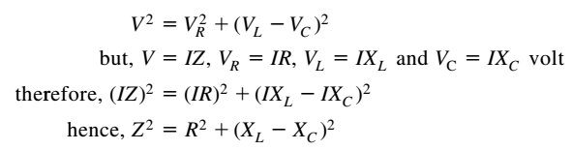



The associated impedance triangle is shown in Fig.3.17. Note that if X C X L, then the circuit phase angle φ will be lagging, instead of leading as shown.

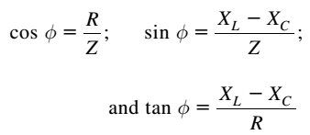

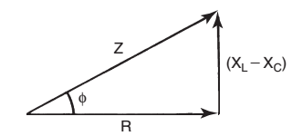

Fig.3.17